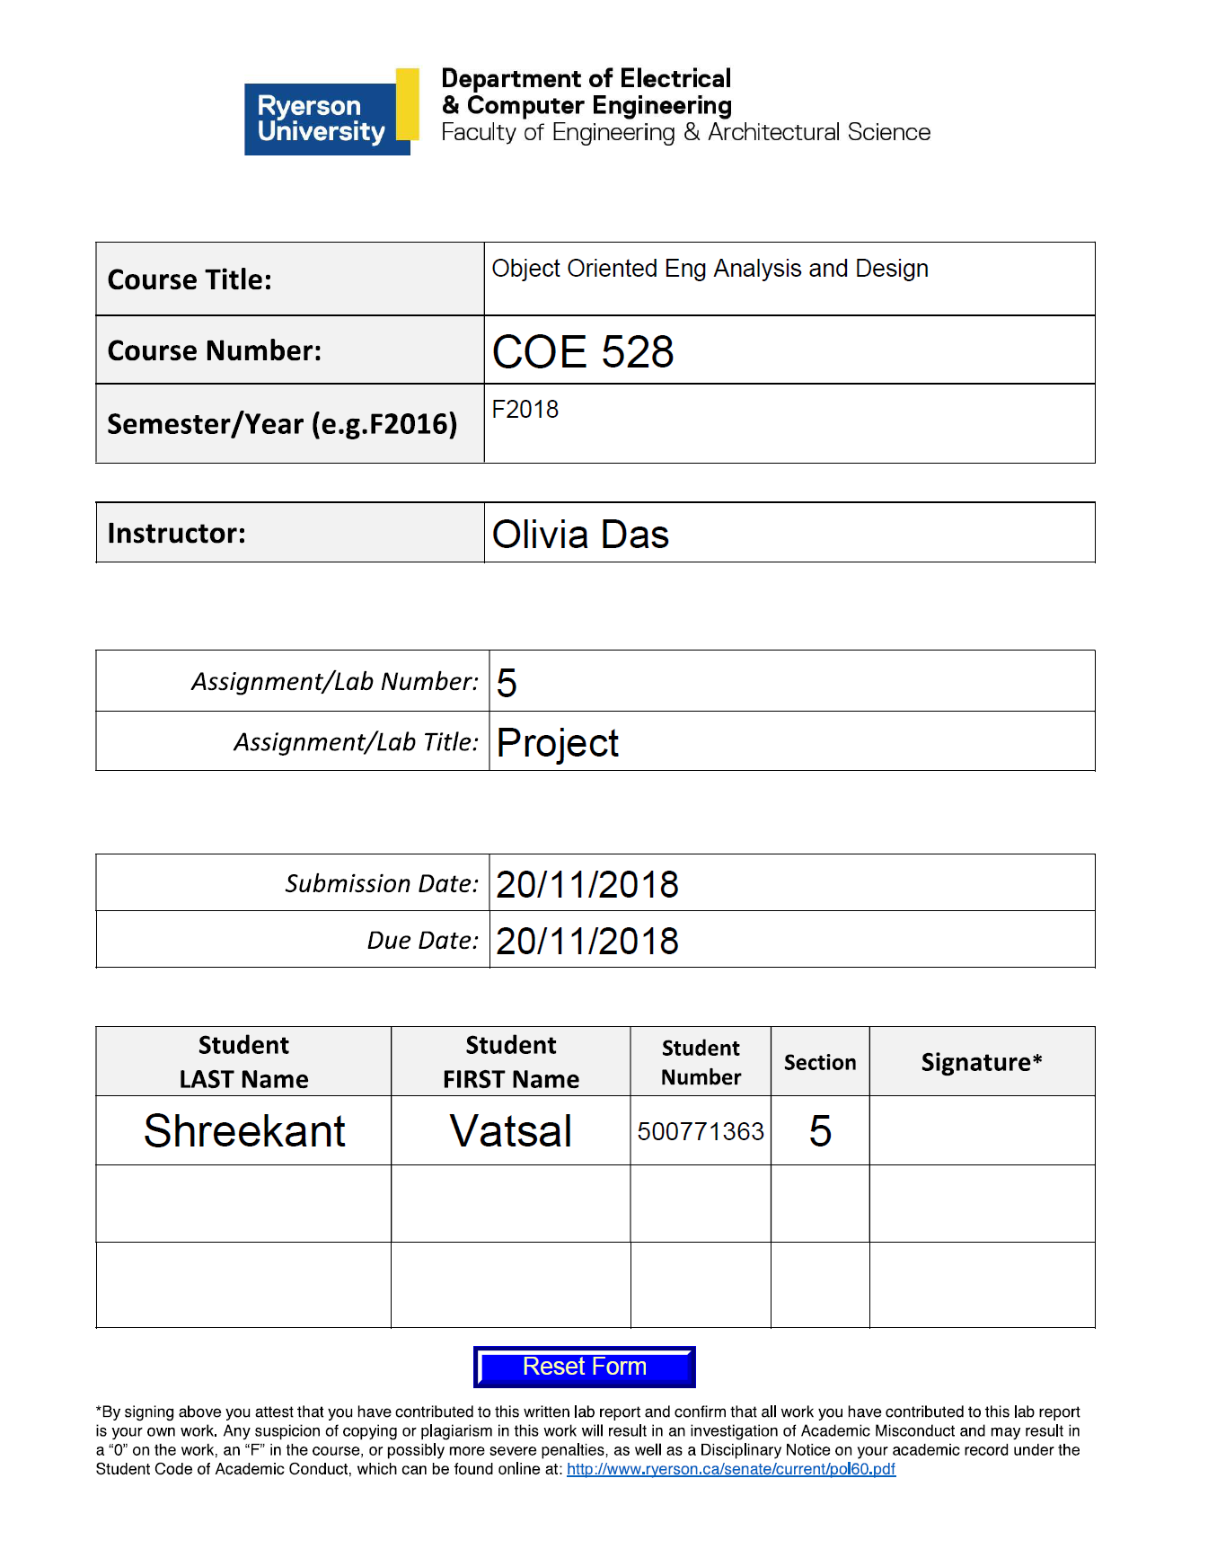

- The Customer being the actor logs in to his/her account by registering their username and password. The login credentials are then verified by making sure that they comply with the specified parameters. The Authenticate is an extends relationship with both logins of the Customer as well as the Manager. The manager being the other actor has the authority to add or delete a customer. When the manager adds a customer, the manager is then asked to create the account with a balance of $100. After doing so, the manager is free to logout and the customer can log in to check the status of his/her account. Followed by the login, the customer is provided with the Transactions page which consists of the following options on the screen: Deposit, Withdrawal, Online Purchase and Logout. If the customer proceeds with the Online Purchase, the customer is then provided with three options of either buying a car, a bike or a hat. Going ahead with either of the purchases a $20 fee is applied to the final amount and when the customer is ready to check out, the program checks for balance in the account to make sure that it is greater than or equal to the final amount from the online shopping.

Use case name Authenticate
Participating actor Communicates with Customer and the Manager
Flow of events …
Entry Condition This use case extends the Login use cases for both the Customer and the Manager actors. It is initiated by the system whenever the either of the actor’s login and input the fields of username and password
Exit Condition …

- In order to describe the Case Diagram, it is best to start off with the profiles involved. There are two types of profiles involved in this application: Customer and Manager. Under the assumption that there is only one manager and zero or more customers use the application. Every customer is assigned only one account. A few of the functions that are assigned to each account include login, logout, deposit, withdraw, get balance and online purchase(s). However, the Manager can only login, logout, add customer and delete customer. Each Customer account has 3 hierarchies associated with it in terms of the status of the account: Silver, Gold and Platinum. The Silver level states that the customer should have less than 10000, the Gold level stipulates that there should be 10000 or more but less than 20000 in their account and finally in order to qualify for Platinum, the customer should have 20000 or more in their account. With every online purchase, a fee of $20 is charged for Silver, $10 with Gold and no fee with Platinum level.

- The class selected for the purposes of Overview, abstraction, rep invariant and Javadoc is the Account class.

- The Statechart diagrams describe a sequence of states an object goes through in response to external events. State, Transition and Actions are the parameters of the Statechart diagram. The part that forms the Statechart design pattern is Authenticate.

